**1.Program to traverse array list 3,17,6,9,7 add these elements and traverse it.**

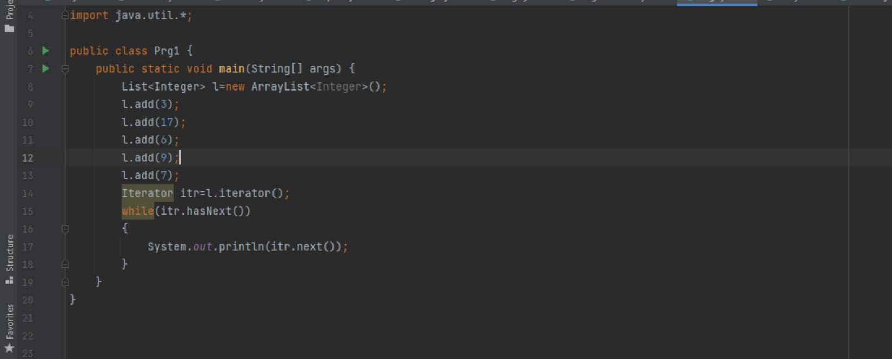

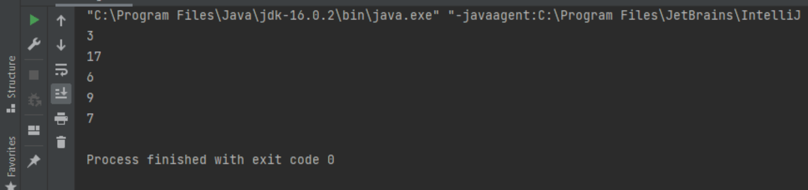

**2.Program to traverse a hashset** **3,17,6,9,7 add these elements and traverse it.**

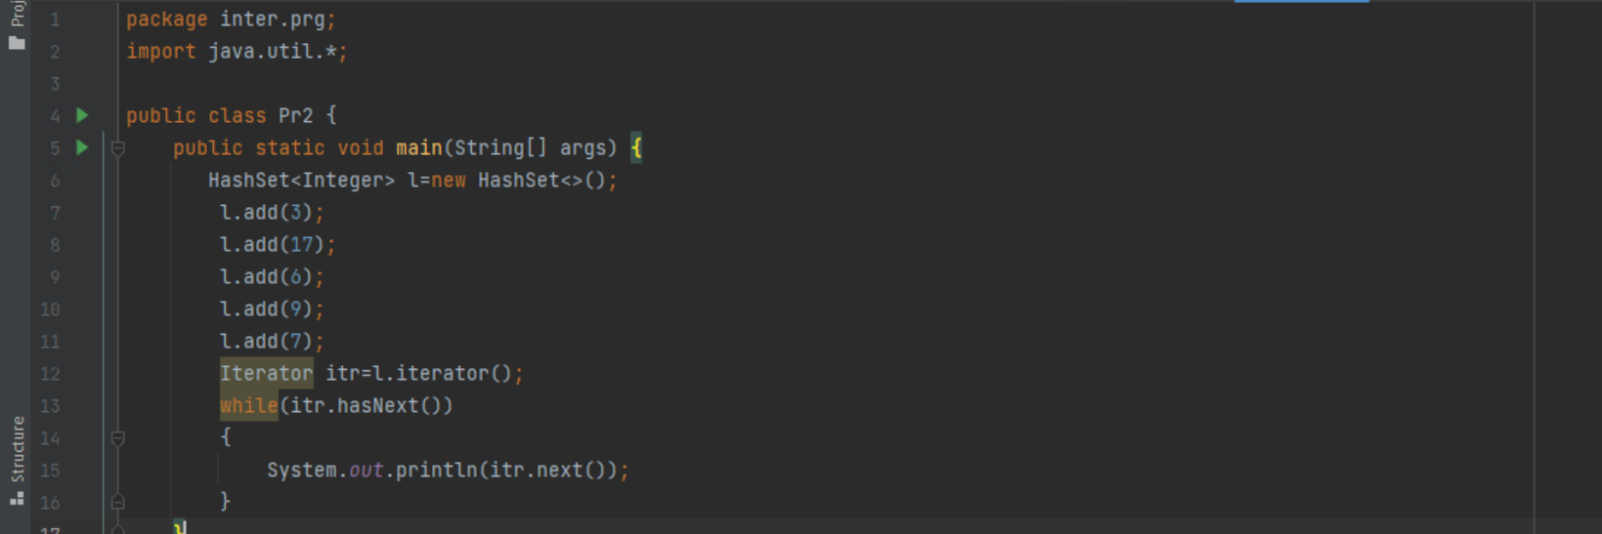

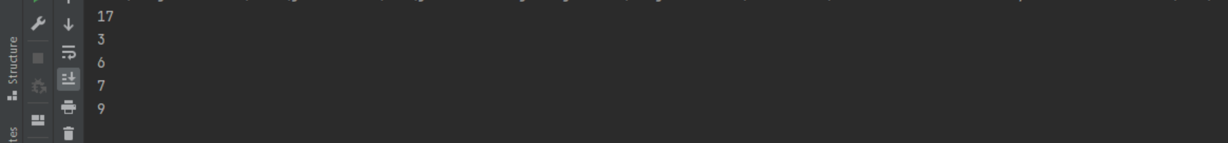

**3.Check if element exist in array list value will be Mumbai, Pune, Delhi, Indore, Lucknow Check the value of Indore exist or not using array list and LinkedList**

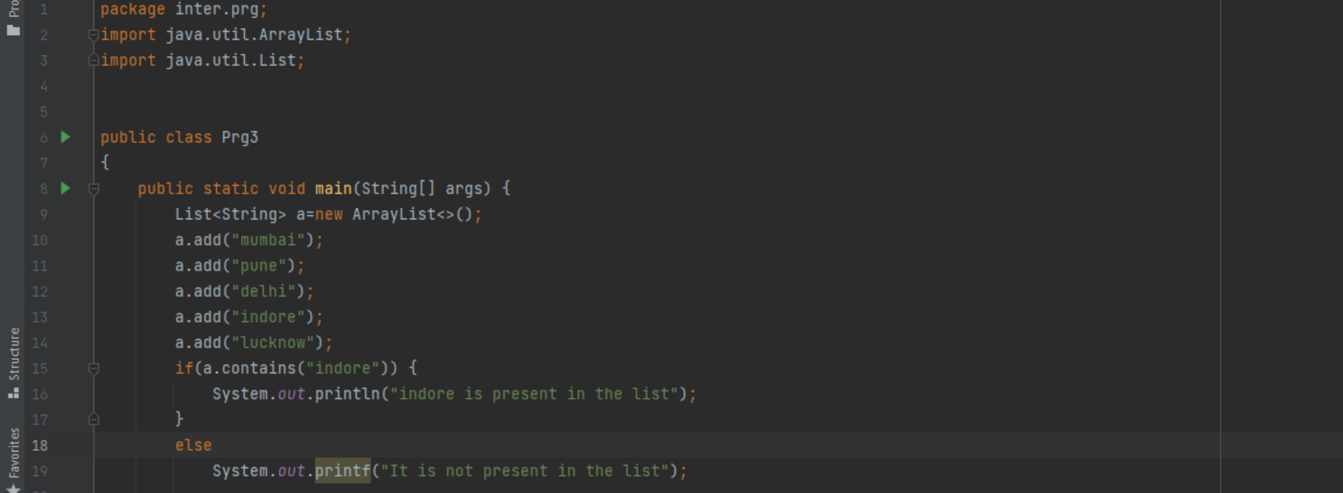

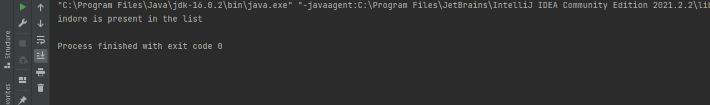

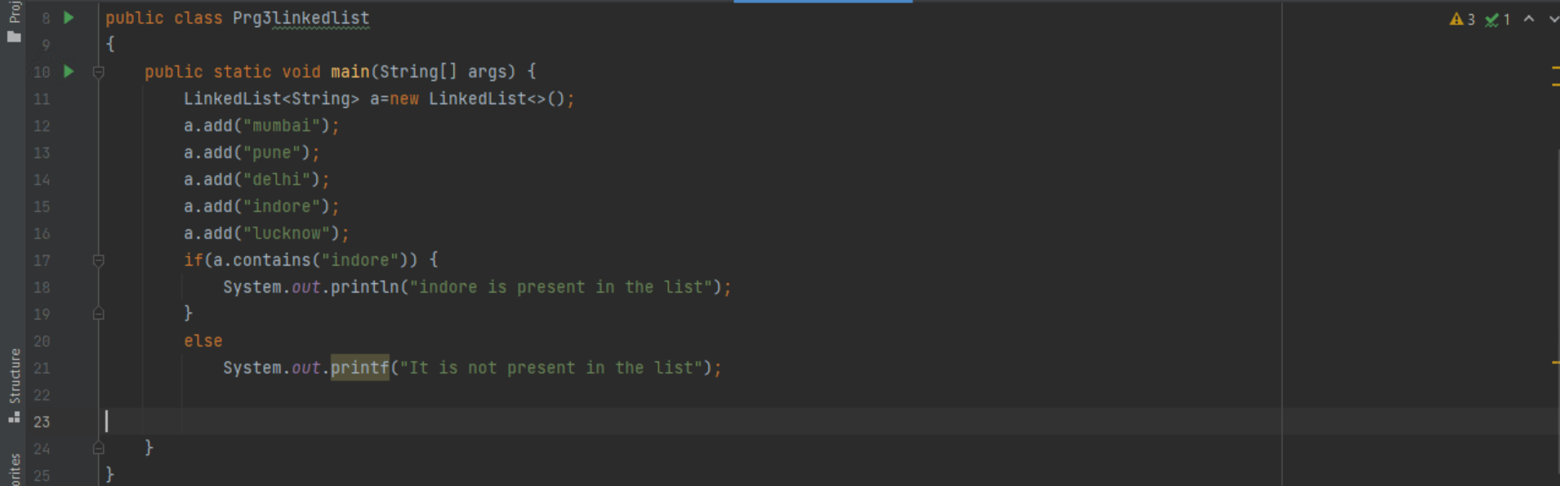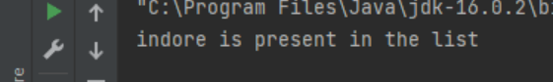

**4.Program for finding length of hash set value will be** **Mumbai, Pune, Delhi Indore, Lucknow**

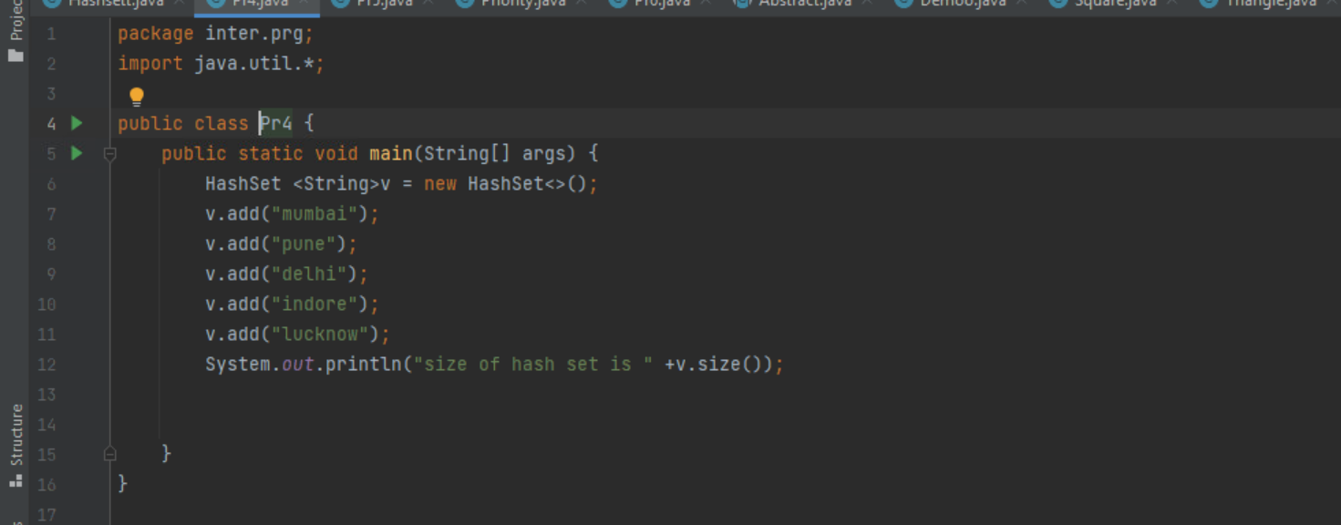

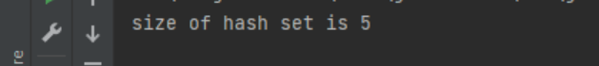

**5.Program for finding size of vector elements 1,5,6,7,8,10 values**

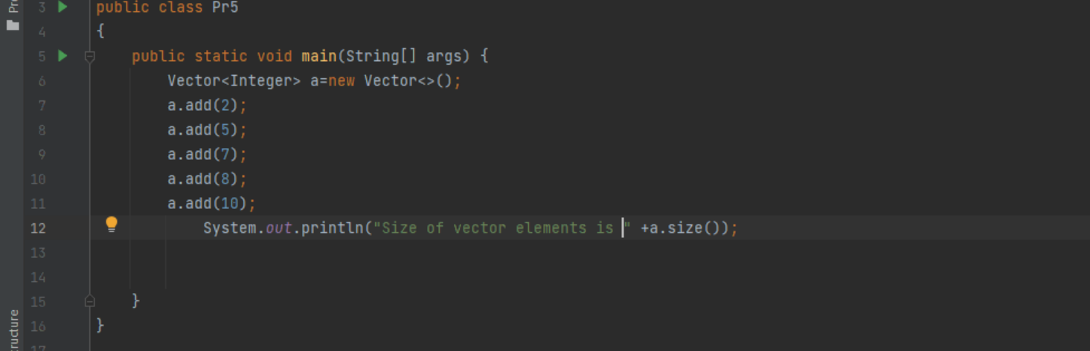

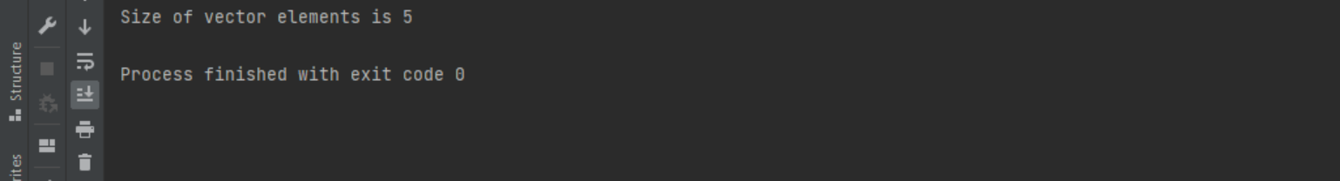

**6. Remove elements from array list**

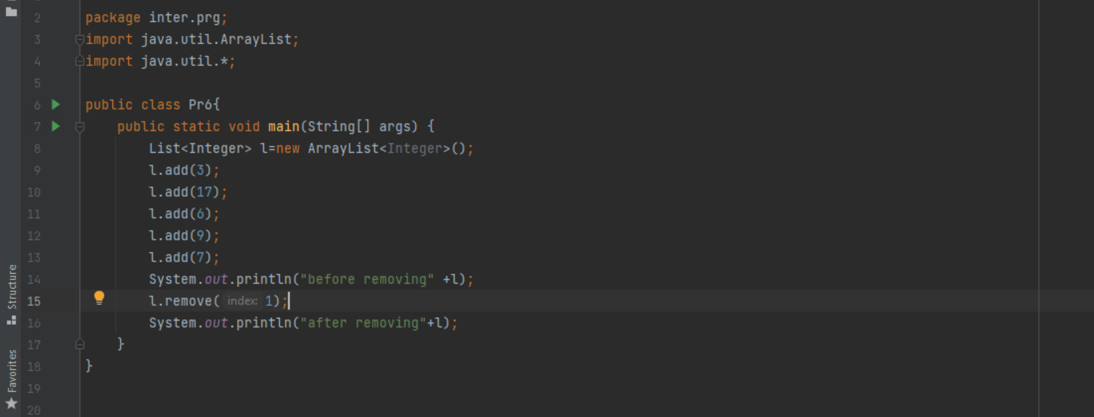

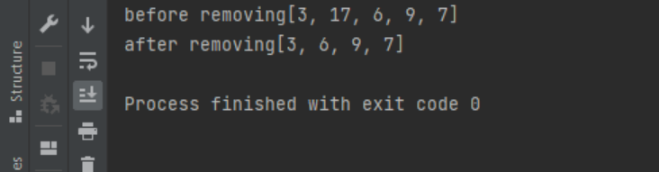

**7. Write a a program to add elements in a queue and print head element using peek method and poll method**

